EXPERIMENT-12
IMPLEMENTATION OF ECC-ELIPTIC CURVE CRYPTOGRAPHY
AIM
To implement Elliptic Curve Cryptography (ECC) for encryption and decryption using elliptic curve operations.
ALGORITHM
- Choose an elliptic curve and a base point.
- Select a private key for the user.
- Calculate the corresponding public key using elliptic curve point multiplication.
- Use the public and private keys for secure encryption/decryption.
- Perform elliptic curve point operations.
- Display the generated keys and resulting values.
CODE:
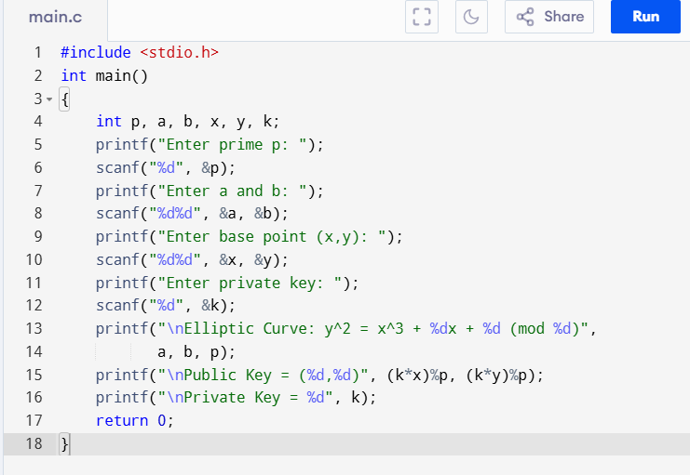
OUTPUT:
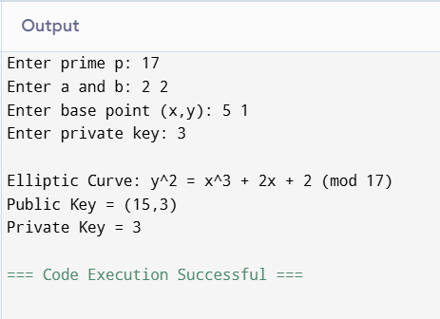
RESULT:
Thus, the basic Elliptic Curve Cryptography (ECC) concept was successfully demonstrated using elliptic curve parameters and key generation.

